**What are agile user stories?**

A user story is the smallest unit of work in an agile framework.

It’s an end goal, not a feature, expressed from the software user’s perspective.

in simple language that outline the desired outcome.

Stories fit neatly into agile frameworks like scrum and kanban.

In scrum, user stories are added to sprints .

Kanban teams pull user stories into their backlog and run them through their workflow.

kanban teams learn how to manage work-in-progress (WIP) and can further refine their workflows.

**Why create user stories?**

Stories enable collaboration-the team can work together to decide how best to serve the user and meet that goal.

Stories drive creative solutions. Stories encourage the team to think critically and creatively .

Stories create momentum. With each passing story, the development team enjoys a small challenge and a small win, driving momentum.

**Working with user stories**

Once a story has been written, it’s time to integrate it into your workflow.

Generally a story is written by the product owner, product manager, or program manager and submitted for review.

What are the acceptance criteria?

Acceptance criteria (AC) are the conditions a software product must meet to be accepted by a user, a customer, or other systems.

They are unique for each user story and define the feature behaviour from the end-user’s perspective.

User acceptance criteria in given/when/then format follows the template: “Scenario: (explain scenario).

Given (how things begin),

when (action taken),

then (outcome of taking action).”

EXAMPLE

For a health clinic’s pre-appointment paperwork:

Given that I’m an existing health centre patient,

When I schedule an appointment online,

Then I will receive the fillable pre-appointment paperwork electronically.

USER Stories

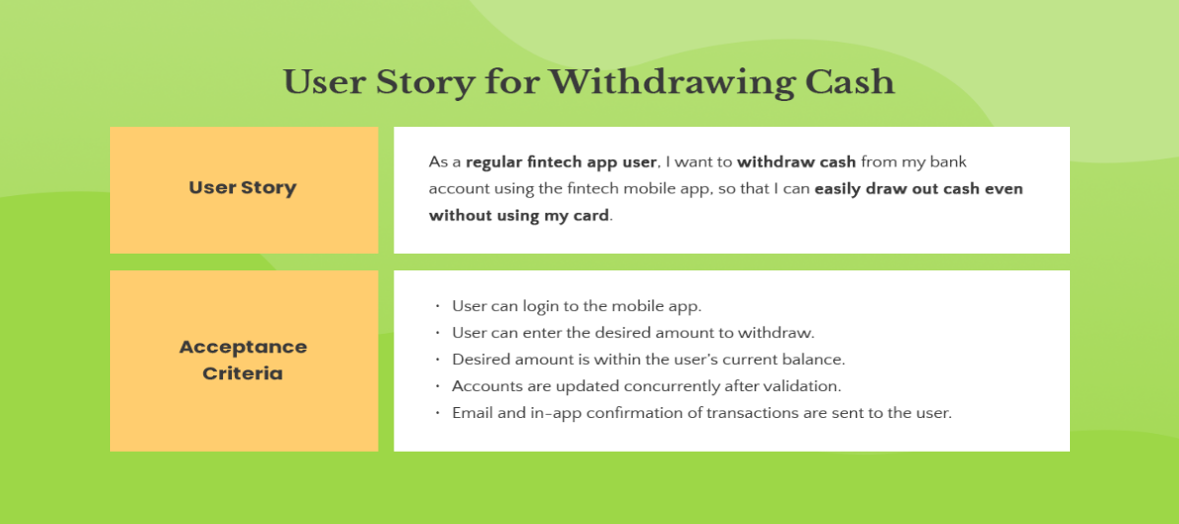

## What is INVEST?

The acronym [**INVEST**](http://xp123.com/articles/invest-in-good-stories-and-smart-tasks/) helps to remember a widely accepted set of criteria, or checklist, to assess the quality of a [**user story**](https://www.agilealliance.org/glossary/user-stories/).

If the story fails to meet one of these criteria, the team may want to reword it, or even consider a rewrite.

A good user story should be:

* “I” ndependent
* “N” egotiable
* “V” aluable
* “E” stimable
* “S” mall)
* “T” estable

Scrum

Scrum is an agile framework for managing and delivering complex projects. It provides a structured yet flexible way for development teams to work collaboratively and deliver high-value products iteratively. Here are key components and concepts associated with Scrum:

Roles:

Product Owner: Represents the stakeholders and defines the product backlog. Responsible for prioritizing features and making decisions on what to build.

Scrum Master: Facilitates the Scrum process, removes impediments, and ensures that the team follows Scrum practices. Acts as a servant-leader for the team.

Development Team: Cross-functional group responsible for delivering the increments of the product. Typically consists of developers, testers, designers, etc.

Events:

Sprint: A time-boxed period (typically 2-4 weeks) during which a potentially releasable product increment is created.

Sprint Planning: A meeting at the beginning of the sprint where the team selects items from the Product Backlog to work on and plans how to achieve the goals.

Daily Scrum: A short, daily stand-up meeting where team members discuss progress, plan for the day, and identify any impediments.

Sprint Review: Held at the end of the sprint, where the team presents the completed work to stakeholders and receives feedback.

Sprint Retrospective: A meeting at the end of each sprint to reflect on the team's performance and identify areas for improvement.

Who is a Product Owner?

A product owner is responsible for ensuring the success of a project in Scrum.

A Scrum framework is an Agile methodology that facilitates communication and self-organization within a team.

A Product Owner is part of the scrum team.

The Product Owner must ensure that the user stories meet customer requirements.

The role of the Product Owner is critical for companies that are keen to move to an agile-based product development methodology.

What is EPIC??

Epics are large bodies of work that can be broken down into a number of smaller tasks (called stories)

Epics are an important practice for agile and DevOps teams.

Epics are a helpful way to organize your work and to create a hierarchy.

Epics help teams break their work down, while continuing to work towards a bigger goal.

.